- Discuss different types of cultural celebrations(ethnic, religious and national) in Bangladesh/ Discuss cultural Traits of Bangladesh.
- Explain globalization’s impact on Bangalee/Bangladeshi culture.
- SWOT analysis of Bangladesh’s geographical location from its geopolitical or geostrategical position
- Define constitution and discuss the types of constitution.
- How can we make a good constitution?/ What are the key features of an ideal constitution?
- Mention the key features and limitations of BD constitution.
- What are the absolute rights in Bangladesh constitutions? Mention the rights on which state can impose reasonable restrictions.
- Define foreign policy and discuss the key principles of Bangladesh foreign policy.
- What are the key challenges for current foreign policy of Bangladesh?/ How do the issues of Rohingya crisis and climate change affect Bangladesh’s foreign policy?
- Describe the key successes of Bangladesh foreign policy/ Can you compare the foreign policy successes of Zia-ur Rahman with Sheikh Mujibur Rahman?

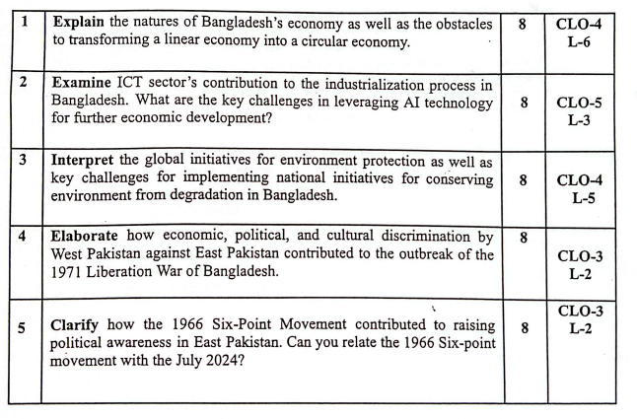

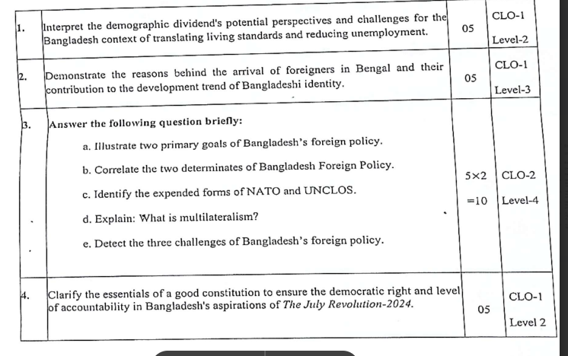
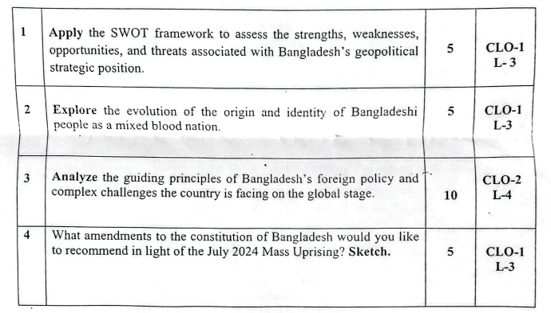

Q1. Discuss different types of cultural celebrations(ethnic, religious and national) in Bangladesh/ Discuss cultural Traits of Bangladesh.

Ans: Cultural Celebrations and Cultural Traits of Bangladesh
Bangladesh is a country rich in cultural diversity and traditions that reflect its long history and religious harmony. The culture of Bangladesh is a beautiful blend of ethnic, religious, and national celebrations, along with unique traits that define the Bangladeshi identity.

1. Ethnic Celebrations
Bangladesh is home to several ethnic communities such as the Chakma, Marma, Garo, Santal, and Manipuri. Each group has its own customs, music, dress, and festivals.
- Biju (Chakma New Year): Celebrated by the Chakma people in the Chittagong Hill Tracts marking the beginning of the new year with dancing, singing, and traditional food.
- Wangala (Garo Harvest Festival): Marks the end of the harvest season and is celebrated with drums, songs, and dances.
- Rongali Bihu, Sangrai, and other tribal carnivals also showcase colorful tribal cultures and ethnic unity.

2. Religious Celebrations
Religious festivals play a major role in Bangladeshi culture and strengthen social harmony among communities.
- Muslim Festivals:
  - Eid-ul-Fitr and Eid-ul-Azha are the biggest celebrations, marked with prayers, feasting, and charity.
  - Eid-e-Miladunnabi commemorates the birth and death of Prophet Muhammad (S).
  - Bishwa Ijtema in Tongi is one of the world’s largest Muslim congregations.
- Hindu Festivals:
  - Durga Puja is the biggest Hindu festival celebrated for ten days across the country.
  - Saraswati Puja, Kali Puja, and Janmashtami are also widely observed.
- Buddhist Festivals:
  - Buddha Purnima and Baishakhi Purnima are celebrated to honor Lord Buddha’s birth, enlightenment, and death.
- Christian Festivals:
  - Christmas (Bara Din) is celebrated with prayers, decorations, and charity, especially in Dhaka and among the Christian communities.

3. National Celebrations
National festivals reflect patriotism and collective pride in the country’s history and achievements.
- Language Movement Day (21 February): Observed to honor the martyrs of the 1952 Language Movement.
- Independence Day (26 March): Marks Bangladesh’s declaration of independence in 1971.
- Victory Day (16 December): Celebrates the victory of Bangladesh in the Liberation War.
- Pohela Boishakh (Bengali New Year): A secular festival symbolizing unity, culture, and a new beginning for all Bangladeshis, regardless of religion.

4. Cultural Traits of Bangladesh
The cultural identity of Bangladesh is shaped by its traditions, lifestyle, and values that have evolved over centuries.
- Language: Bangla is the official and state language; it symbolizes national unity and pride.
- Food: Rice and fish are the staple diet, captured in the proverb “Mache bhate Bangali.”
- Dress: Men wear lungi and panjabi, while women wear sari or salwar kameez.
- Music and Dance: Folk genres like Baul, Bhatiali, Murshidi, and Marfati are popular; Rabindra Sangeet and Nazrul Geeti enrich modern culture.
- Art and Craft: Nakshi Kantha, pottery, and folk paintings express rural creativity.
- Sports: Kabaddi is the national game; cricket is the most popular sport.
- Values: Hospitality, family bonding, respect for elders, and community life are central to Bangladeshi culture.

- Q.What is the constitution? Describe the fundamental principles of the Bangladesh constitution.
Ans: A constitution is a set of rules and principles that explains how a country is governed. It defines the powers of the government, the rights of the citizens, and the relationship between the government and the people.
In short, it is the supreme law of a country that guides all laws and institutions.
Fundamental Principles of the Bangladesh Constitution (Article 8–12):
These principles are the guidelines for running the state. They reflect the spirit of the Liberation War and the goals of independence.
- Nationalism (Article 9):
Based on the unity, language, and culture of the Bangladeshi people that developed through the freedom struggle.
- Socialism (Article 10):
The state aims to remove inequality and ensure fair distribution of wealth so that everyone can live decently.
- Democracy (Article 11):
The people have the right to elect their representatives. It ensures people’s participation, equality, and freedom.
- Secularism (Article 12):
Every person has the right to follow their own religion freely, and no religion can be used for political benefit.
These four ideas — nationalism, socialism, democracy, and secularism — are the foundation of the Bangladesh Constitution
b) What are the fundamental rights of the people of Bangladesh according to the constitution? (Explain at least 5 rights)
Ans: The Constitution of Bangladesh (Part III, Articles 26–47A) gives citizens several fundamental rights to protect their freedom, equality, and dignity. These rights ensure that all people are treated fairly and can live safely under the rule of law.
Here are some important fundamental rights explained simply:
- Equality before Law (Article 27):
All citizens are equal before the law. No one can get special treatment or be discriminated against because of wealth, gender, religion, or social status.
- Non-Discrimination (Article 28):
The state cannot discriminate against anyone based on religion, race, caste, gender, or place of birth. Men and women have equal rights in every sphere of life.
- Equality of Opportunity in Public Employment (Article 29):
Every citizen has the right to apply for government jobs and should get fair treatment in employment.
- Freedom of Speech and Expression (Article 39):
Every citizen has the right to express their thoughts and opinions freely, as long as it does not harm others or go against national interest or law.
- Freedom of Religion (Article 41):
People can follow, practice, and spread their own religion peacefully. The government cannot force anyone to follow a specific religion.
- Protection of Life and Liberty (Article 32):
Every person has the right to live freely and safely. No one can be arrested, punished, or killed without proper legal process.
- Freedom of Movement (Article 36):
Citizens can move freely throughout Bangladesh and live or work anywhere they want, unless restricted by law for public safety.
- Freedom of Assembly and Association (Articles 37–38):
People have the right to gather peacefully and form groups, organizations, or political parties for social or political purposes.
- Protection of Property (Article 42):
Every citizen has the right to own, use, and transfer property. No one’s property can be taken by the government without proper reason and compensation.
- Prohibition of Forced Labour (Article 34):
No one can be forced to work against their will, except in cases like national service required by law.
- Protection in Respect of Trial and Punishment (Article 35):
No one can be punished twice for the same offence, and everyone has the right to a fair trial. Torture or cruel treatment is forbidden.
- Right to Vote (Article 122):
Every adult citizen of sound mind (18 years or older) has the right to vote and choose their representatives freely.
c) Can Bangladesh shift to an unwritten constitution now? Explain. Ans: No, Bangladesh cannot shift to an unwritten constitution now.
Reasons:
- Bangladesh has a written constitution since 1972.
It clearly defines the powers of the government, citizens’ rights, and state principles.
- Unwritten constitutions (like in the UK) depend on customs and traditions, but Bangladesh does not have such long-established political traditions.
- A written constitution ensures stability.
Changing to an unwritten one would create confusion and legal problems.
- Article 7 of the Constitution states that the constitution is the supreme law of Bangladesh — this cannot be replaced by unwritten customs.
- People’s trust and democracy depend on a written set of laws. Removing that would weaken democracy and governance.
So, Bangladesh must continue with its written constitution to protect democracy, rule of law, and citizens’ rights.

Q.How can we make a good constitution?/ What are the key features of an ideal constitution? Ans: A constitution is the most important law of a country. A good constitution helps the government run smoothly, ensures people’s rights, and maintains peace and justice in society. It should also be flexible enough to meet the needs of time and people.
Here are the main features of a good or ideal constitution:

1. Written and Clear
A good constitution should be written in a proper and organized way. It should be clear so that citizens, government officials, and courts can easily understand it. A written constitution helps avoid confusion and ensures everyone follows the same rules.

2. Supremacy of the Constitution
The constitution must be the highest law of the country. All other laws, policies, and government actions must follow it. If any law goes against the constitution, it should be declared invalid. This ensures that the government never becomes more powerful than the law.

3. Balance Between Flexibility and Stability
A good constitution should not be too rigid or too flexible. It should be possible to amend (change) it when society or the world changes, but it should also protect the basic structure of the state from frequent changes.

4. Protection of Fundamental Rights
A good constitution must ensure basic rights for all citizens, such as equality, freedom, justice, and security. These rights protect people from unfair treatment by others or by the government.

5. Separation of Powers
There should be a clear division of powers among the three organs of government — the Legislature (makes laws), the Executive (implements laws), and the Judiciary (interprets laws). This prevents misuse of power and ensures that no single branch controls everything.

6. Democratic and Representative Government
The constitution should establish a government that is elected by the people. Leaders must be responsible and answerable to the citizens. This helps maintain democracy and makes sure the government works for the welfare of the people.

7. Rule of Law
Everyone in the country, including leaders and government officials, must obey the law. No one is above the law. This principle protects citizens from injustice and keeps equality in society.

8. Independent Judiciary
The judiciary must be independent and free from political pressure. Judges should be able to give fair and neutral decisions. This helps to maintain justice and protect people’s rights.

9. Decentralization of Power
Power should not stay only in the central government. Local governments should have authority to manage their own areas. This ensures that local problems are solved faster and that citizens take part in governance.

10. Simple and Understandable Language
The language of the constitution should be simple and easy to read. Complicated language may cause confusion or misinterpretation. When people can understand their rights and duties clearly, they can follow the law better.

11. Sovereignty of the People
A good constitution must clearly show that the people are the main source of power. The government exists to serve the people, and citizens have the right to change the government through elections if it fails to work properly.

12. Fair and Free Election System
A constitution must guarantee free, fair, and regular elections. This ensures that citizens can choose their representatives without fear or influence, and it keeps democracy alive.

